WEEK1 – Data Structures and Alogorithms HandsOn

Execrcise2: Objective: To implement linear and binary search for product search optimization in an e-commerce system and analyze their performance.

STEPS :

Understanding Asymptotic Notation Big O Notation Overview:

* Big O (O): Worst-case runtime.
* Big Ω (Omega): Best-case runtime.
* Big Θ (Theta): Average-case runtime.

Why it matters in search:

Algorithm Best Case Average Case Worst Case

|  |  |  |
| --- | --- | --- |
| Linear Search O(1) | O(n) | O(n) |
| Binary Search O(1) | O(log n) | O(log n) |

Product.java :

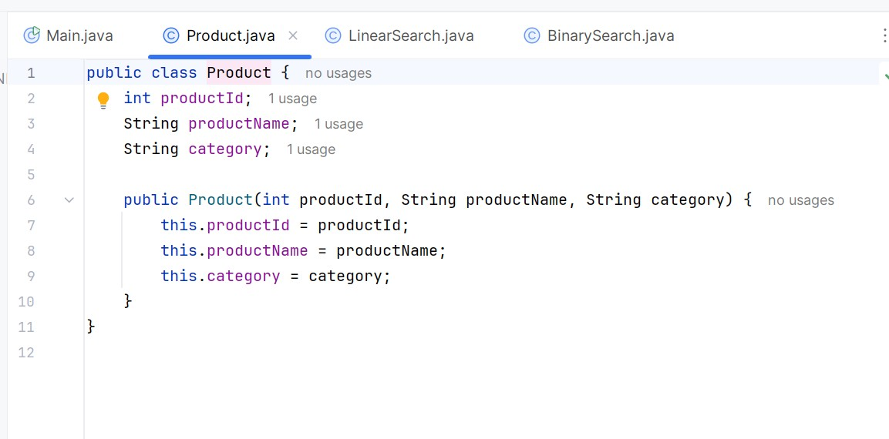

Linear Search Implementation:

LinearSearch.java :

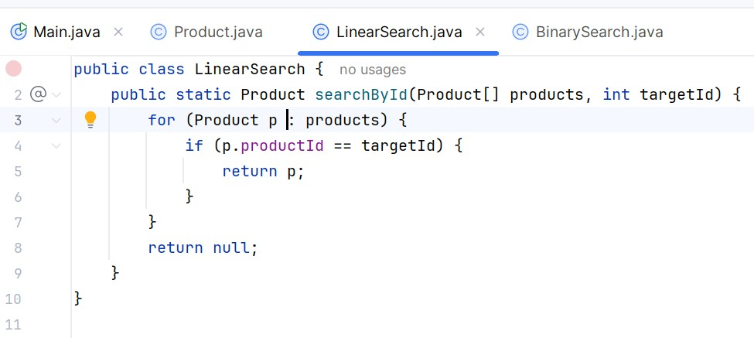

BinarySearch Implementation:

BinarySearch.java :

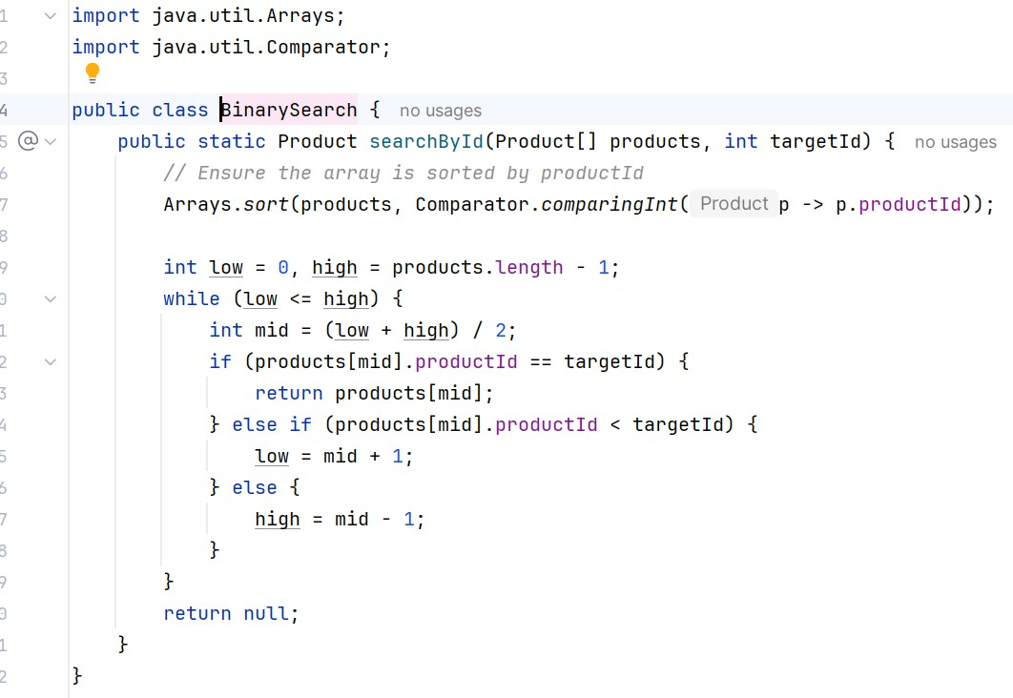

Main.java :

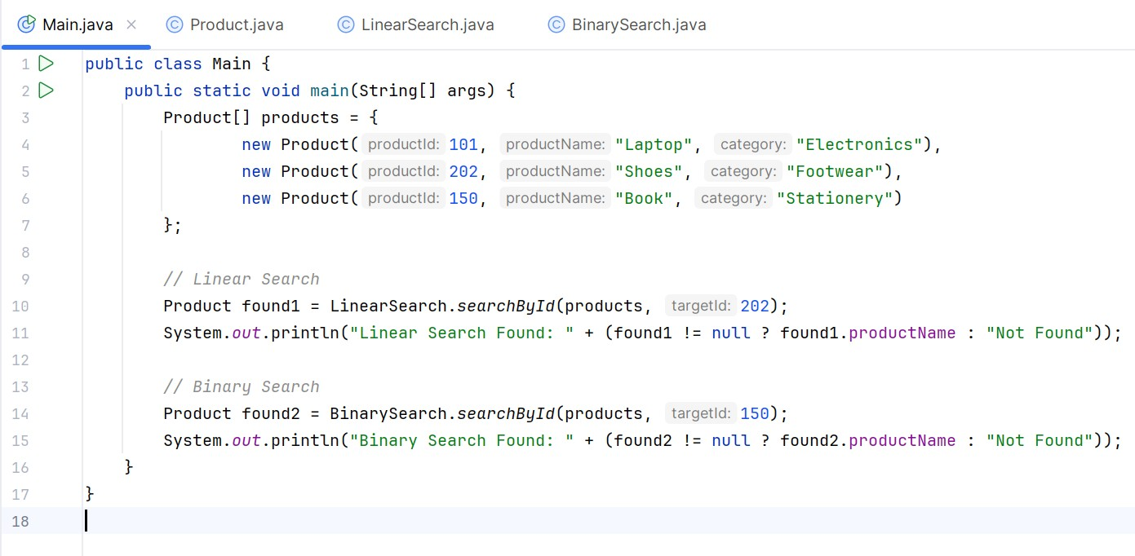

Output :

